**SAMPLE EXAMPLE OF RANDOM FOREST ALGORITHM:**

**CODE:**

#The problem here is to predict the gas consumption (in millions of gallons) in 48 of the US states based on petrol tax (in cents),

#per capita income (dollars), paved highways (in miles) and the proportion of population with the driving license.

import pandas as pd

import numpy as np

dataset = pd.read_csv('petrol_consumption.csv')

dataset.head()

dataset.tail()

#Preparing Data for training

X = dataset.iloc[:, 0:4].values

y = dataset.iloc[:, 4].values

from sklearn.model_selection import train_test_split

X_train, X_test, y_train, y_test = train_test_split(X, y, test_size=0.2, random_state=0)

#Feature Scaling

from sklearn.preprocessing import StandardScaler

sc = StandardScaler()

X_train = sc.fit_transform(X_train)

X_test = sc.transform(X_test)

#Training

from sklearn.ensemble import RandomForestRegressor

regressor = RandomForestRegressor(n_estimators=20, random_state=0)

regressor.fit(X_train, y_train)

y_pred = regressor.predict(X_test)

**OUTPUT:**

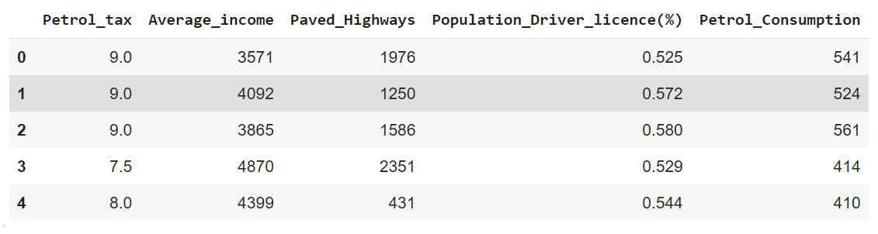

*Data set glimpses*

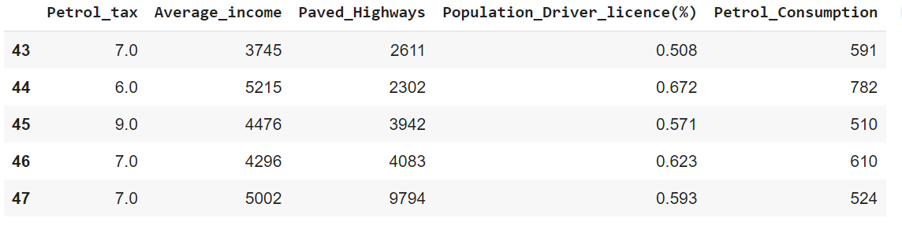

*Data set glimpses*

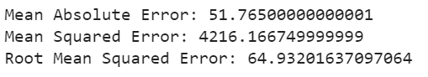

*RMSE with 20 Trees*

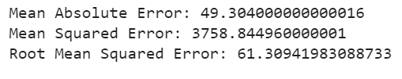

*RMSE with 50 Trees*

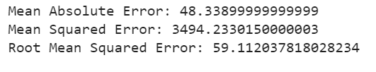

*RMSE with 200 Trees*

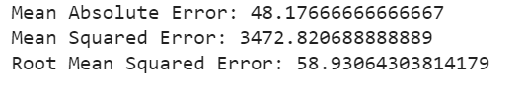

*RMSE with 300 Trees*

*You can see that the error values decreases with the increase in number of estimator. After 200 the rate of decrease in error diminishes, so therefore 200 is a good number for n_estimators*